**The History of Castleford Library**

By the turn of the nineteenth century more people were able to read, but books and newspapers were unaffordable for the masses. In 1841 an average miner in a town like Castleford earned around 9-13 old pence a week, while *The Times* cost 4d (old pence) per single issue (Bentley and Lound, 2005, p.13). There were several early attempts to make reading more accessible to Castleford residents. A subscription newsroom where fee payers could read local and national newspapers came into existence in the 1840s, but very little is known about it. In the 1850s a ‘Mechanics Institute’ was opened in Castleford. Mechanics Institutes were venues for working class people to take evening classes to learn new skills and experience culture (i.e. dancing and music) outside normal working hours. In 1858 the Castleford branch moved to Sagar Street, and included a library for its members. However, over the years its membership gradually fell and it struggled to meet building costs.

Shortly afterwards in 1865 the Co-Operative Society opened, which very soon in 1866 included a members library which was open Saturday evenings. Within only two years the library had around 200 books with a catalogue for members (Bentley and Lound, 2005, p.18). Industrialist Sir Titus Salt, then resident at Methley Hall, gave a £2 donation for the library to purchase books for the people. But the founding donation was a donation of books from Mr Henry Pitman, editor of the Cooperative newspaper. The first librarian of this library was Mr Martin Walters.

With the Mechanics Institute failing, in 1902 its secretary Mr Padgett and the Urban District Council wrote to Andrew Carnegie. From 1882-1919 this Scottish-born industrialist financed 2811 libraries worldwide, saying he wished ‘to promote the advancement and diffusion of knowledge’ for all (Carnegie, 1881. In: Bentley and Lound, 2005, p.20). Carnegie donated £2500 to the creation of a public library in Castleford. The Council chose a site on Carlton Street between the Municipal Offices and Market Hall. The Mechanics Institute handed over their books to the Council, and the Sagar Street Librarian, Christopher Robinson, became the Free Libraries’ first librarian. G.H. Vernon Cale, an architect from Birmingham, won the competition to design the new building and set to work in 1903 (CLEW, c.2013).

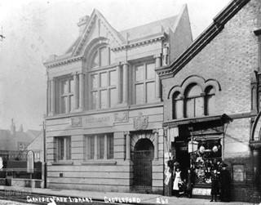

The library officially opened on 30 November 1905. Visitors entering would have come into the tiled, green-walled Borrowers Hall. It led off to the Lending Library at the front and the ‘Reading and Newsroom’ at the back. A grand staircase led up to the first floor, with the Ladies Reading Room at the back and the Reference Library at the front. The Librarian’s Office was in the centre on the first floor, with little slots positioned for them to spy on the rooms!

The library was free to all Castleford rate-payers (non-ratepayers would pay a penny per year). Children under 14 were not allowed in the building and although there was not yet a specific section, children’s books were in the Lending Library and gradually became popular. In 1905-31 the number of children’s books rose from 120-1036 (Bentley and Lound, 2005, p.69). In those early days the library operated a ‘close access’ policy where borrowers were not allowed to touch the shelves and books! Instead they had to choose books from a catalogue and library staff would retrieve them.

Although it has kept the same Carlton Street building, Castleford Library has changed greatly over the years, largely because of Castleford’s population growing and to accommodate more books. In 1928-32 the Lending Library was moved further back, and in its place was the new Ladies Reading Room. In place of the old Ladies Reading Room upstairs a Museum was opened. A Children’s Department opened at the back of the building on its present-day site. During this time the library became ‘open access’, allowing customers to pick up books as they pleased. Again in 1943-4 the library went through a reshuffle to create more space, which saw non-fiction books moved upstairs and the old Reading Room was moved into the Ladies Reading Room.

In 1955-56 Castleford Library underwent another refurbishment, which required the place to temporarily relocate to Ferrybridge Road. During the process the Museum moved upstairs to its current site, non-fiction was greatly expanded and new staff rooms with a kitchenette created on the first floor.

The old Reading Room progressively became used less as newspapers and magazines became more available. In 1985 it was replaced with the ‘Recorded Sound Department’ and is now at the very front of the ground floor, with tables for reading and crafts.

[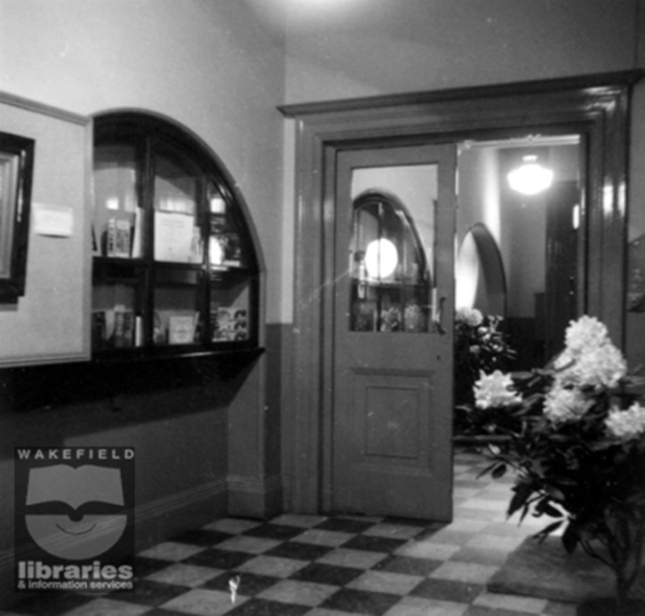](https://wakefieldlibraries.files.wordpress.com/2024/03/picture2-3.jpg)The entrance to the library, 1956[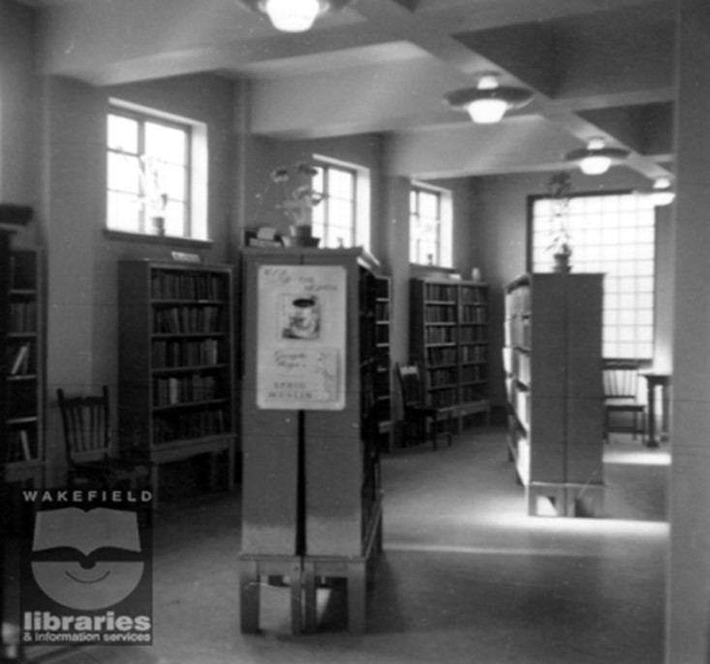](https://wakefieldlibraries.files.wordpress.com/2024/03/picture3-1.jpg)The fiction section in 1956.[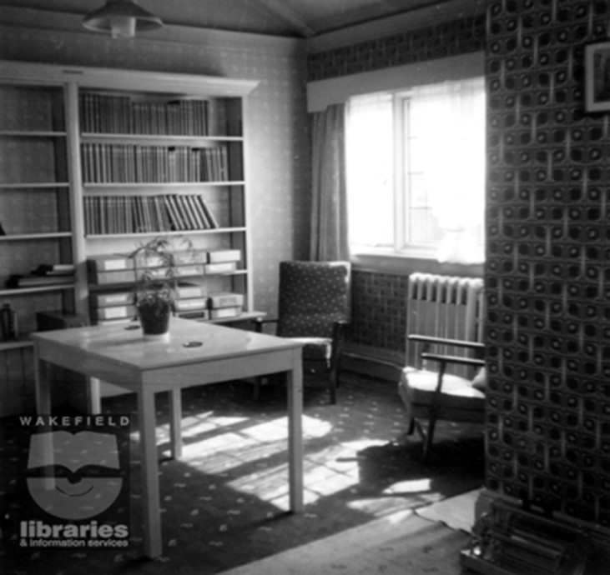](https://wakefieldlibraries.files.wordpress.com/2024/03/picture4-1.jpg)The old Librarian’s office, 1956.

[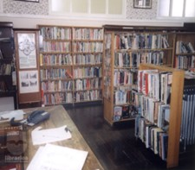](https://wakefieldlibraries.files.wordpress.com/2024/03/picture5-2.jpg)

The non-fiction department upstairs, 1998.

[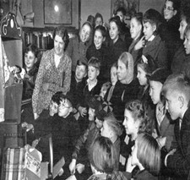](https://wakefieldlibraries.files.wordpress.com/2024/03/picture6-2.jpg)

Children’s story time, 1950s.

[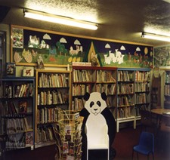](https://wakefieldlibraries.files.wordpress.com/2024/03/picture7-3.jpg)

The children’s section, 1998.

Since 1998, the library has been supported by its dedicated FOCAL (Friends of Castleford Library) group. As well as helping to run events, the group has campaigned and worked to refurbish the building. In 2001 they got microfilm readers for the library, allowing people to look at historic newspapers easier.

[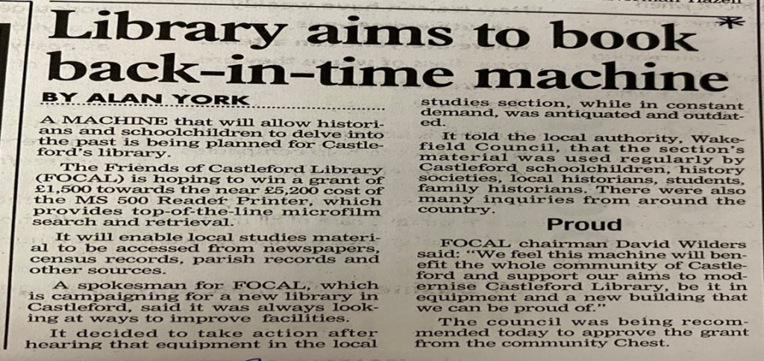](https://wakefieldlibraries.files.wordpress.com/2024/03/picture8.jpg)

This campaigning led to another refurbishment in 2013, which warranted the library opening at temporary accommodation on Sagar Street. This time the rear of the building was entirely demolished and replaced with a three storey structure, enabling the museum to have a third floor at the rear all of its own. A lift was created to enable access to all floors for the disabled and elderly. The old Librarian’s Office and staff room above were replaced with more space for non-fiction and local history books. The wooden help desks were replaced with modern ones and the building re-carpeted and re-painted and fully restocked. The remodelled library reopened in 2015.

**References**

*Books*

Bentley, P.L. and Lound, M (2005) *Castleford Free Library, 1905-2005*. Castleford Press, Castleford.

*Photographs*

Twixt, Aire and Calder (c.1905) *The Carnegie Free Library at Castleford early 1900s*. [online]. [Date Accessed: 27 February 2024]. Available at: <https://www.twixtaireandcalder.org.uk/image-detail/?id=3103>.

Twixt, Aire and Calder (1956) *Castleford Library After Alterations, 1956*. [online]. [Date Accessed: 27 February 2024]. Available at: <https://www.twixtaireandcalder.org.uk/image-detail/?id=6565>

Twixt, Aire and Calder (1956) *Castleford Library After Alterations, 1956*. [online]. [Date Accessed: 27 February 2024]. Available at: <https://www.twixtaireandcalder.org.uk/image-detail/?id=6917>

Twixt, Aire and Calder (1956) *Castleford Library After Alterations, 1956*. [online]. [Date Accessed: 27 February 2024]. Available at: <https://www.twixtaireandcalder.org.uk/image-detail/?id=7195>

Twixt, Aire and Calder (1998)*The non-Fiction Department at Castleford Library, 1998*. [online]. [Date Accessed: 27 February 2024]. Available at: <https://www.twixtaireandcalder.org.uk/image-detail/?id=2816>

Twixt, Aire and Calder (1956)*Children’s Hour at Castleford Library*. [online]. [Date Accessed: 27 February 2024]. Available at: <https://www.twixtaireandcalder.org.uk/image-detail/?id=3310>

Twixt, Aire and Calder (1998) *The Children’s Department at Castleford Library 1998*. [online]. [Date Accessed: 27 February 2024]. Available at: <https://www.twixtaireandcalder.org.uk/image-detail/?id=2695>

*Webpages*

The Carnegie Legacy in England and Wales (c.2013) *Castleford Library*. [online]. [Date Accessed: February 3 2024]. Available at: <https://carnegielegacyinengland.wordpress.com/2016/09/04/castleford-library/>

*Newspapers*

York, A (2001) ‘Library aims to book back in time!’. *Yorkshire Evening Post*. No pagination.